MARKING OF ENVELOPES

FIRST ENVELOPE
Original – Legal and Technical Component
BIDDER’S NAME & ADDRESS
ORIGINAL – LEGAL & TECHNICAL COMPONENT
PROPOSED PROCUREMENT OF THE SUPPLY AND DELIVERY OF LIBRARY BOOKS
FOR USTP-CDO CAMPUS CY 2026
(Contract No. USTP- GSPB02-03-2026-26-19640)

ABC: P3,250,000.00

DO NOT OPEN BEFORE MAY 05, 2026, 09:30 A.M.
USTP – CDO CAMPUS BIDS AND AWARDS COMMITTEE
UNIVERSITY OF SCIENCE AND TECHNOLOGY OF SOUTHERN PHILIPPINES
C.M. RECTO AVE., LAPASAN, CAGAYAN DE ORO CITY

USTsP - CDO Campus Bids And Awards Committee
University of Science and Technology of Southern Philippines
C.M. Recto Ave., Lapasan, Cagayan de Oro City

Copy No. 1 – Legal and Technical Component
BIDDER’S NAME & ADDRESS
COPY NO. 1 – LEGAL & TECHNICAL COMPONENT

USTP – CDO CAMPUS BIDS AND AWARDS COMMITTEE
UNIVERSITY OF SCIENCE AND TECHNOLOGY OF SOUTHERN PHILIPPINES
C.M. RECTO AVE., LAPASAN, CAGAYAN DE ORO CITY

PROPOSED PROCUREMENT OF THE SUPPLY AND DELIVERY OF LIBRARY BOOKS
FOR USTP-CDO CAMPUS CY 2026
(Contract No. USTP- GSPB02-03-2026-26-19640)

ABC: P3,250,000.00

DO NOT OPEN BEFORE MAY 05, 2026, 09:30 A.M.

OUTER – Legal and Technical Component
BIDDER’S NAME & ADDRESS
LEGAL & TECHNICAL COMPONENT
USTP – CDO CAMPUS BIDS AND AWARDS COMMITTEE
UNIVERSITY OF SCIENCE AND TECHNOLOGY OF SOUTHERN PHILIPPINES
C.M. RECTO AVE., LAPASAN, CAGAYAN DE ORO CITY

PROPOSED PROCUREMENT OF THE SUPPLY AND DELIVERY OF LIBRARY BOOKS
FOR USTP-CDO CAMPUS CY 2026
(Contract No. USTP- GSPB02-03-2026-26-19640)

ABC: P3,250,000.00

USTsP - CDO Campus Bids And Awards Committee
University of Science and Technology of Southern Philippines
C.M. Recto Ave., Lapasan, Cagayan de Oro City

DO NOT OPEN BEFORE MAY 05, 2026, 09:30 A.M.

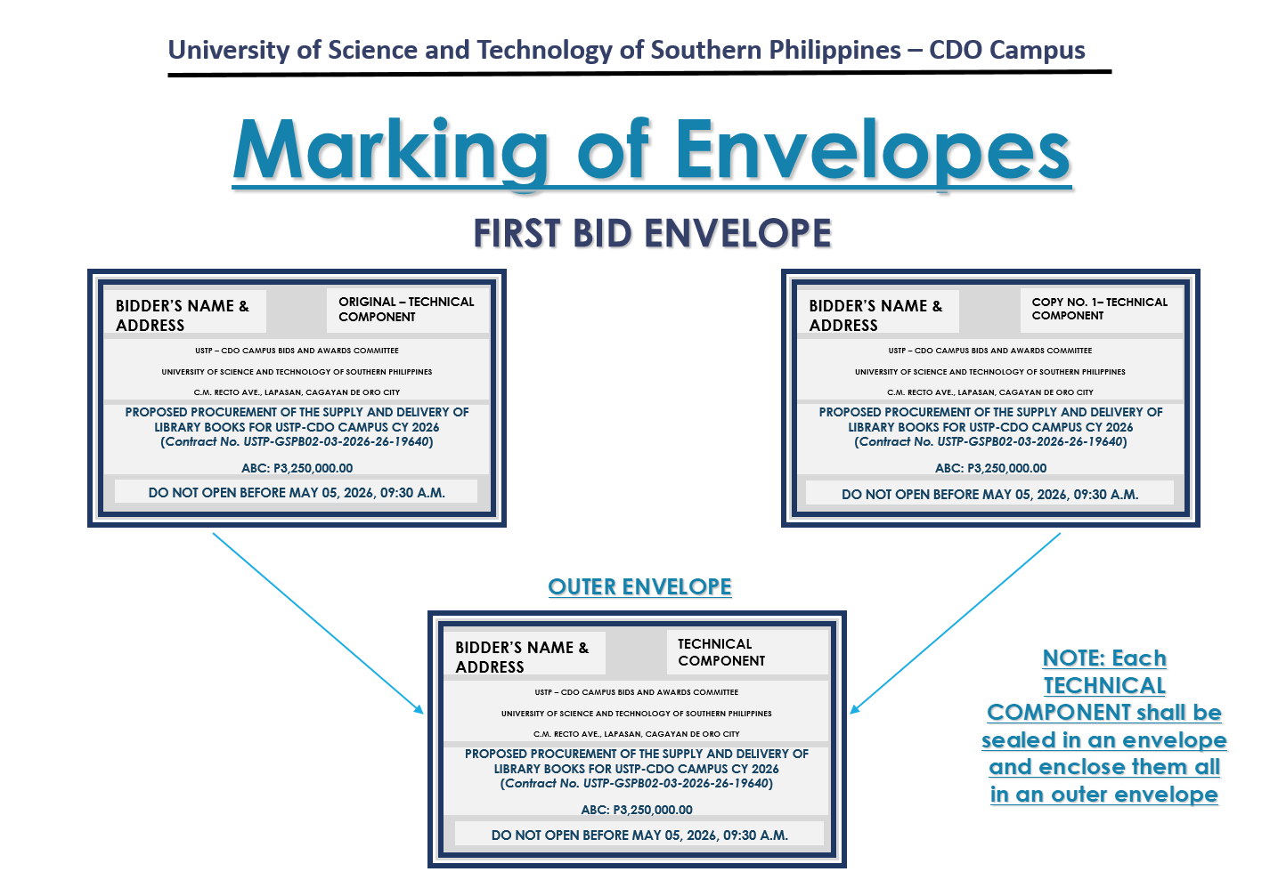
SECOND ENVELOPE
Original – Financial Component
BIDDER’S NAME & ADDRESS
ORIGINAL – FINANCIAL COMPONENT
USTP – CDO CAMPUS BIDS AND AWARDS COMMITTEE
UNIVERSITY OF SCIENCE AND TECHNOLOGY OF SOUTHERN PHILIPPINES
C.M. RECTO AVE., LAPASAN, CAGAYAN DE ORO CITY

PROPOSED PROCUREMENT OF THE SUPPLY AND DELIVERY OF LIBRARY BOOKS
FOR USTP-CDO CAMPUS CY 2026
(Contract No. USTP- GSPB02-03-2026-26-19640)

ABC: P3,250,000.00

DO NOT OPEN BEFORE MAY 05, 2026, 09:30 A.M.

Copy No. 1 – Financial Component

BIDDER’S NAME & ADDRESS
COPY NO. 1– FINANCIAL COMPONENT

USTP – CDO CAMPUS BIDS AND AWARDS COMMITTEE
UNIVERSITY OF SCIENCE AND TECHNOLOGY OF SOUTHERN PHILIPPINES
C.M. RECTO AVE., LAPASAN, CAGAYAN DE ORO CITY

PROPOSED PROCUREMENT OF THE SUPPLY AND DELIVERY OF LIBRARY BOOKS
FOR USTP-CDO CAMPUS CY 2026
(Contract No. USTP- GSPB02-03-2026-26-19640)

ABC: P3,250,000.00

DO NOT OPEN BEFORE MAY 05, 2026, 09:30 A.M.

OUTER – Financial Component
PROPOSED PROCUREMENT OF THE SUPPLY AND DELIVERY OF LIBRARY BOOKS
FOR USTP-CDO CAMPUS CY 2026
(Contract No. USTP- GSPB02-03-2026-26-19640)

ABC: P3,250,000.00

BIDDER’S NAME & ADDRESS
FINANCIAL COMPONENT
USTP – CDO CAMPUS BIDS AND AWARDS COMMITTEE
UNIVERSITY OF SCIENCE AND TECHNOLOGY OF SOUTHERN PHILIPPINES
C.M. RECTO AVE., LAPASAN, CAGAYAN DE ORO CITY
DO NOT OPEN BEFORE MAY 05, 2026, 09:30 A.M.

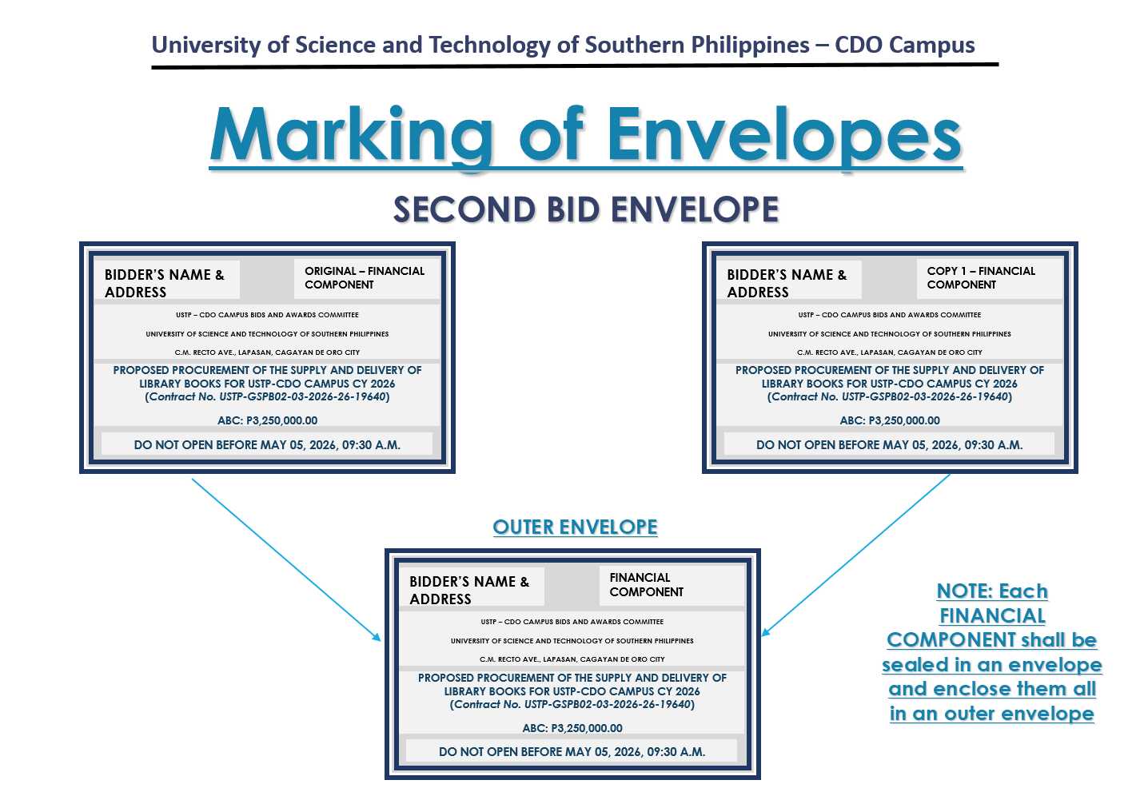

OUTER ENVELOPE
BIDDER’S NAME & ADDRESS
USTP – CDO CAMPUS BIDS AND AWARDS COMMITTEE
UNIVERSITY OF SCIENCE AND TECHNOLOGY OF SOUTHERN PHILIPPINES
C.M. RECTO AVE., LAPASAN, CAGAYAN DE ORO CITY

PROPOSED PROCUREMENT OF THE SUPPLY AND DELIVERY OF LIBRARY BOOKS
FOR USTP-CDO CAMPUS CY 2026
(Contract No. USTP- GSPB02-03-2026-26-19640)

ABC: P3,250,000.00

DO NOT OPEN BEFORE MAY 05, 2026, 09:30 A.M.

