MARKING OF ENVELOPES

FIRST ENVELOPE
Original – Technical Component
BIDDER’S NAME & ADDRESS
ORIGINAL – TECHNICAL COMPONENT
PROPOSED PROCUREMENT OF THE SUPPLY AND DELIVERY FOR AIRACK: AI-DRIVEN HYBRID-POWERED SMART DATA CABINET WITH INTELLIGENT THERMAL AND POWER MANAGEMENT FOR SUSTAINABLE IT OPERATIONS FOR USTP-CDO CAMPUS CY 2026
(Contract No. USTP-GSPB06-07-2026-3716-26705)

ABC: ₱3,490,224.00
DO NOT OPEN BEFORE JULY 27, 2026, 09:30 A.M.
USTP – CDO CAMPUS BIDS AND AWARDS COMMITTEE
UNIVERSITY OF SCIENCE AND TECHNOLOGY OF SOUTHERN PHILIPPINES
C.M. RECTO AVE., LAPASAN, CAGAYAN DE ORO CITY

USTsP - CDO Campus Bids And Awards Committee
University of Science and Technology of Southern Philippines
C.M. Recto Ave., Lapasan, Cagayan de Oro City

Copy No. 1 – Technical Component
BIDDER’S NAME & ADDRESS
COPY NO. 1 – TECHNICAL COMPONENT

USTP – CDO CAMPUS BIDS AND AWARDS COMMITTEE
UNIVERSITY OF SCIENCE AND TECHNOLOGY OF SOUTHERN PHILIPPINES
C.M. RECTO AVE., LAPASAN, CAGAYAN DE ORO CITY

PROPOSED PROCUREMENT OF THE SUPPLY AND DELIVERY FOR AIRACK: AI-DRIVEN HYBRID-POWERED SMART DATA CABINET WITH INTELLIGENT THERMAL AND POWER MANAGEMENT FOR SUSTAINABLE IT OPERATIONS FOR USTP-CDO CAMPUS CY 2026
(Contract No. USTP-GSPB06-07-2026-3716-26705)

ABC: ₱3,490,224.00

DO NOT OPEN BEFORE JULY 27, 2026, 09:30 A.M.

OUTER – Technical Component
BIDDER’S NAME & ADDRESS
TECHNICAL COMPONENT
USTP – CDO CAMPUS BIDS AND AWARDS COMMITTEE
UNIVERSITY OF SCIENCE AND TECHNOLOGY OF SOUTHERN PHILIPPINES
C.M. RECTO AVE., LAPASAN, CAGAYAN DE ORO CITY

PROPOSED PROCUREMENT OF THE SUPPLY AND DELIVERY FOR AIRACK: AI-DRIVEN HYBRID-POWERED SMART DATA CABINET WITH INTELLIGENT THERMAL AND POWER MANAGEMENT FOR SUSTAINABLE IT OPERATIONS FOR USTP-CDO CAMPUS CY 2026
(Contract No. USTP-GSPB06-07-2026-3716-26705)

ABC: ₱3,490,224.00

USTsP - CDO Campus Bids And Awards Committee
University of Science and Technology of Southern Philippines
C.M. Recto Ave., Lapasan, Cagayan de Oro City

DO NOT OPEN BEFORE JULY 27, 2026, 09:30 A.M.

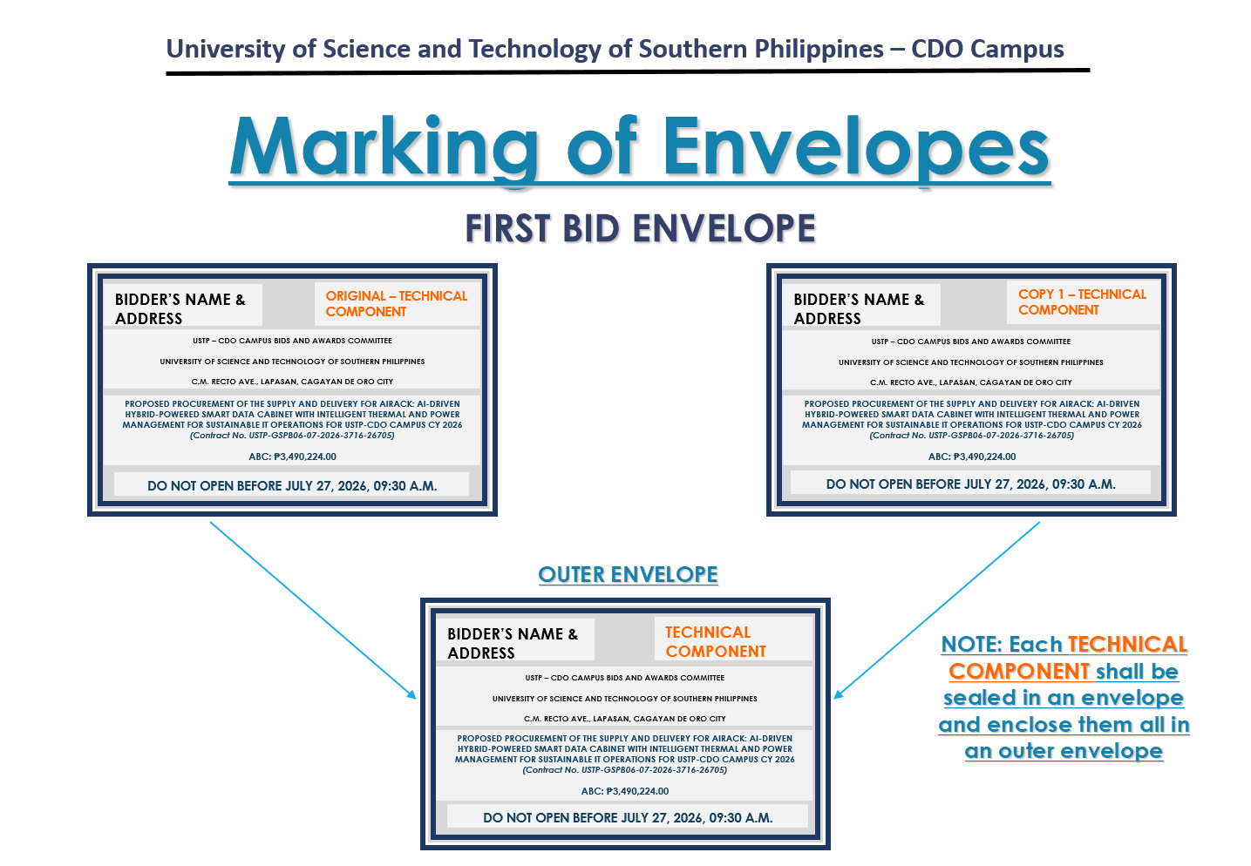

SECOND ENVELOPE
Original – Financial Component
BIDDER’S NAME & ADDRESS
ORIGINAL – FINANCIAL COMPONENT
USTP – CDO CAMPUS BIDS AND AWARDS COMMITTEE
UNIVERSITY OF SCIENCE AND TECHNOLOGY OF SOUTHERN PHILIPPINES
C.M. RECTO AVE., LAPASAN, CAGAYAN DE ORO CITY

PROPOSED PROCUREMENT OF THE SUPPLY AND DELIVERY FOR AIRACK: AI-DRIVEN HYBRID-POWERED SMART DATA CABINET WITH INTELLIGENT THERMAL AND POWER MANAGEMENT FOR SUSTAINABLE IT OPERATIONS FOR USTP-CDO CAMPUS CY 2026
(Contract No. USTP-GSPB06-07-2026-3716-26705)

ABC: ₱3,490,224.00

DO NOT OPEN BEFORE JULY 27, 2026, 09:30 A.M.

Copy No. 1 – Financial Component

BIDDER’S NAME & ADDRESS
COPY NO. 1– FINANCIAL COMPONENT

USTP – CDO CAMPUS BIDS AND AWARDS COMMITTEE
UNIVERSITY OF SCIENCE AND TECHNOLOGY OF SOUTHERN PHILIPPINES
C.M. RECTO AVE., LAPASAN, CAGAYAN DE ORO CITY

PROPOSED PROCUREMENT OF THE SUPPLY AND DELIVERY FOR AIRACK: AI-DRIVEN HYBRID-POWERED SMART DATA CABINET WITH INTELLIGENT THERMAL AND POWER MANAGEMENT FOR SUSTAINABLE IT OPERATIONS FOR USTP-CDO CAMPUS CY 2026
(Contract No. USTP-GSPB06-07-2026-3716-26705)

ABC: ₱3,490,224.00

DO NOT OPEN BEFORE JULY 27, 2026, 09:30 A.M.

OUTER – Financial Component
BIDDER’S NAME & ADDRESS
FINANCIAL COMPONENT
USTP – CDO CAMPUS BIDS AND AWARDS COMMITTEE
UNIVERSITY OF SCIENCE AND TECHNOLOGY OF SOUTHERN PHILIPPINES
C.M. RECTO AVE., LAPASAN, CAGAYAN DE ORO CITY

PROPOSED PROCUREMENT OF THE SUPPLY AND DELIVERY FOR AIRACK: AI-DRIVEN HYBRID-POWERED SMART DATA CABINET WITH INTELLIGENT THERMAL AND POWER MANAGEMENT FOR SUSTAINABLE IT OPERATIONS FOR USTP-CDO CAMPUS CY 2026
(Contract No. USTP-GSPB06-07-2026-3716-26705)

ABC: ₱3,490,224.00

DO NOT OPEN BEFORE JULY 27, 2026, 09:30 A.M.

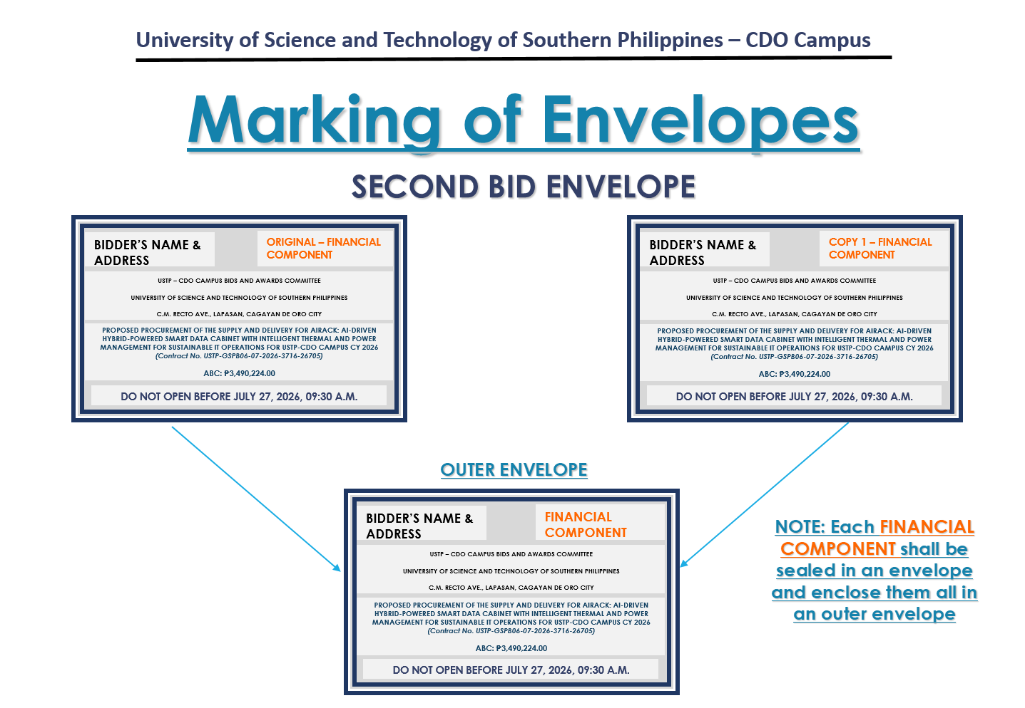

OUTER ENVELOPE
BIDDER’S NAME & ADDRESS
USTP – CDO CAMPUS BIDS AND AWARDS COMMITTEE
UNIVERSITY OF SCIENCE AND TECHNOLOGY OF SOUTHERN PHILIPPINES
C.M. RECTO AVE., LAPASAN, CAGAYAN DE ORO CITY

PROPOSED PROCUREMENT OF THE SUPPLY AND DELIVERY FOR AIRACK: AI-DRIVEN HYBRID-POWERED SMART DATA CABINET WITH INTELLIGENT THERMAL AND POWER MANAGEMENT FOR SUSTAINABLE IT OPERATIONS FOR USTP-CDO CAMPUS CY 2026 (Contract No. USTP-GSPB06-07-2026-3716-26705)
ABC: ₱3,490,224.00

DO NOT OPEN BEFORE JULY 27, 2026, 09:30 A.M.

