MARKING OF ENVELOPES

FIRST ENVELOPE
Original – Technical Component
BIDDER’S NAME & ADDRESS
ORIGINAL – TECHNICAL COMPONENT
Proposed Procurement of the Supply, Delivery, Installation and Commissioning of Electro-Mechanical Technology (EMT) Laboratory Equipment and 3D Printer for USTP-Villanueva Campus CY 2026
(CONTRACT NO. USTP-GSPB03-07-2026-3585-24414)

ABC: P3,117,885.88
LOT 1 – P2,929,928.93 (EMT LABORATORY EQUIPMENT) AND LOT 2 – P187,956.95 (3D PRINTER)

DO NOT OPEN BEFORE AUGUST 18, 2026, 01:30 P.M.
USTP – CDO CAMPUS BIDS AND AWARDS COMMITTEE
UNIVERSITY OF SCIENCE AND TECHNOLOGY OF SOUTHERN PHILIPPINES
C.M. RECTO AVE., LAPASAN, CAGAYAN DE ORO CITY

USTsP - CDO Campus Bids And Awards Committee
University of Science and Technology of Southern Philippines
C.M. Recto Ave., Lapasan, Cagayan de Oro City

Copy No. 1 – Technical Component
BIDDER’S NAME & ADDRESS
COPY NO. 1 – TECHNICAL COMPONENT

USTP – CDO CAMPUS BIDS AND AWARDS COMMITTEE
UNIVERSITY OF SCIENCE AND TECHNOLOGY OF SOUTHERN PHILIPPINES
C.M. RECTO AVE., LAPASAN, CAGAYAN DE ORO CITY

Proposed Procurement of the Supply, Delivery, Installation and Commissioning of Electro-Mechanical Technology (EMT) Laboratory Equipment and 3D Printer for USTP-Villanueva Campus CY 2026
(CONTRACT NO. USTP-GSPB03-07-2026-3585-24414)

ABC: P3,117,885.88
LOT 1 – P2,929,928.93 (EMT LABORATORY EQUIPMENT) AND LOT 2 – P187,956.95 (3D PRINTER)

DO NOT OPEN BEFORE AUGUST 18, 2026, 01:30 P.M.

OUTER – Technical Component
BIDDER’S NAME & ADDRESS
TECHNICAL COMPONENT
USTP – CDO CAMPUS BIDS AND AWARDS COMMITTEE
UNIVERSITY OF SCIENCE AND TECHNOLOGY OF SOUTHERN PHILIPPINES
C.M. RECTO AVE., LAPASAN, CAGAYAN DE ORO CITY

Proposed Procurement of the Supply, Delivery, Installation and Commissioning of Electro-Mechanical Technology (EMT) Laboratory Equipment and 3D Printer for USTP-Villanueva Campus CY 2026
(CONTRACT NO. USTP-GSPB03-07-2026-3585-24414)

ABC: P3,117,885.88
LOT 1 – P2,929,928.93 (EMT LABORATORY EQUIPMENT) AND LOT 2 – P187,956.95 (3D PRINTER)

USTsP - CDO Campus Bids And Awards Committee
University of Science and Technology of Southern Philippines
C.M. Recto Ave., Lapasan, Cagayan de Oro City

DO NOT OPEN BEFORE AUGUST 18, 2026, 01:30 P.M.

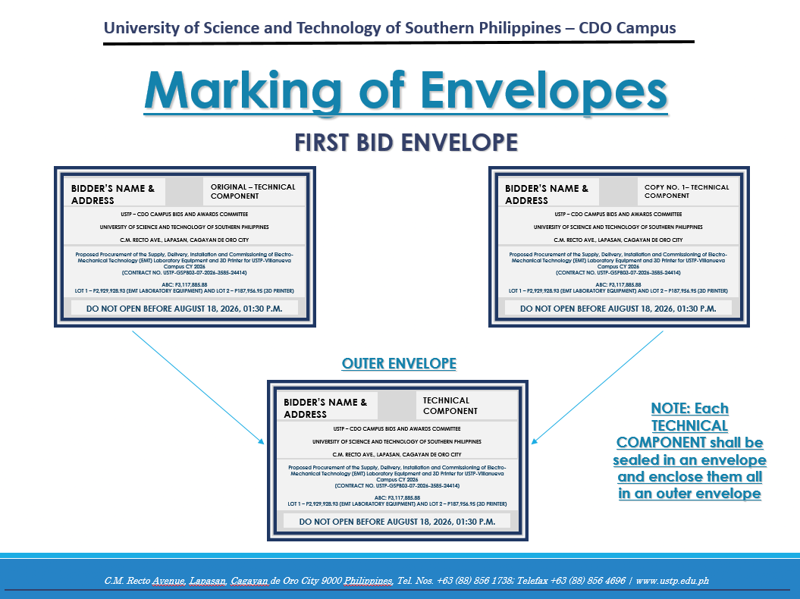

SECOND ENVELOPE
Original – Financial Component
BIDDER’S NAME & ADDRESS
ORIGINAL – FINANCIAL COMPONENT
USTP – CDO CAMPUS BIDS AND AWARDS COMMITTEE
UNIVERSITY OF SCIENCE AND TECHNOLOGY OF SOUTHERN PHILIPPINES
C.M. RECTO AVE., LAPASAN, CAGAYAN DE ORO CITY

Proposed Procurement of the Supply, Delivery, Installation and Commissioning of Electro-Mechanical Technology (EMT) Laboratory Equipment and 3D Printer for USTP-Villanueva Campus CY 2026
(CONTRACT NO. USTP-GSPB03-07-2026-3585-24414)

ABC: P3,117,885.88
LOT 1 – P2,929,928.93 (EMT LABORATORY EQUIPMENT) AND LOT 2 – P187,956.95 (3D PRINTER)

DO NOT OPEN BEFORE AUGUST 18, 2026, 01:30 P.M.

Copy No. 1 – Financial Component

BIDDER’S NAME & ADDRESS
COPY NO. 1– FINANCIAL COMPONENT

USTP – CDO CAMPUS BIDS AND AWARDS COMMITTEE
UNIVERSITY OF SCIENCE AND TECHNOLOGY OF SOUTHERN PHILIPPINES
C.M. RECTO AVE., LAPASAN, CAGAYAN DE ORO CITY

Proposed Procurement of the Supply, Delivery, Installation and Commissioning of Electro-Mechanical Technology (EMT) Laboratory Equipment and 3D Printer for USTP-Villanueva Campus CY 2026
(CONTRACT NO. USTP-GSPB03-07-2026-3585-24414)

ABC: P3,117,885.88
LOT 1 – P2,929,928.93 (EMT LABORATORY EQUIPMENT) AND LOT 2 – P187,956.95 (3D PRINTER)

DO NOT OPEN BEFORE AUGUST 18, 2026, 01:30 P.M.

OUTER – Financial Component
BIDDER’S NAME & ADDRESS
FINANCIAL COMPONENT
USTP – CDO CAMPUS BIDS AND AWARDS COMMITTEE
UNIVERSITY OF SCIENCE AND TECHNOLOGY OF SOUTHERN PHILIPPINES
C.M. RECTO AVE., LAPASAN, CAGAYAN DE ORO CITY

Proposed Procurement of the Supply, Delivery, Installation and Commissioning of Electro-Mechanical Technology (EMT) Laboratory Equipment and 3D Printer for USTP-Villanueva Campus CY 2026
(CONTRACT NO. USTP-GSPB03-07-2026-3585-24414)

ABC: P3,117,885.88
LOT 1 – P2,929,928.93 (EMT LABORATORY EQUIPMENT) AND LOT 2 – P187,956.95 (3D PRINTER)

DO NOT OPEN BEFORE AUGUST 18, 2026, 01:30 P.M.

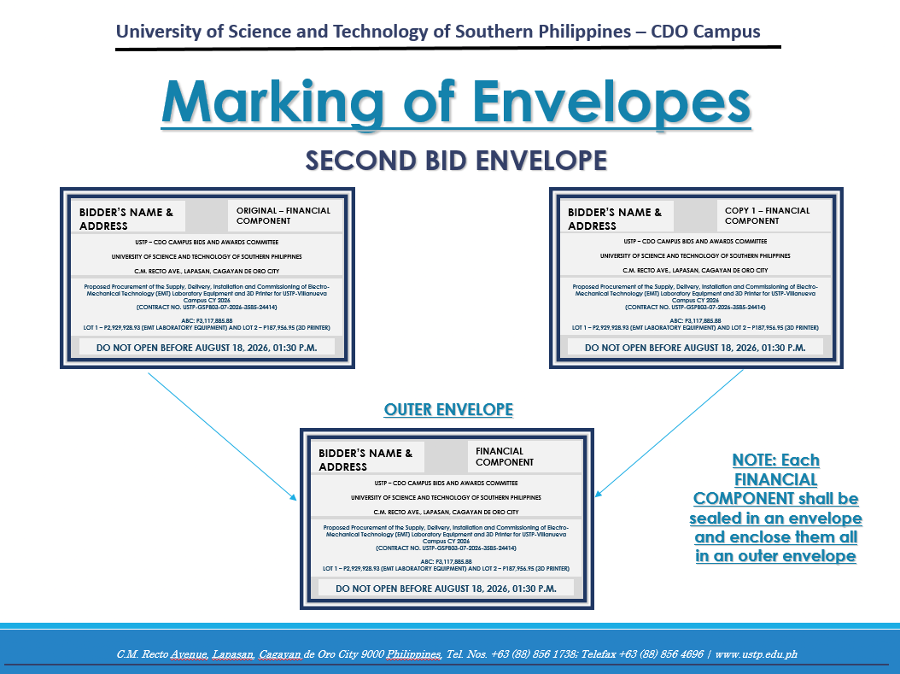

OUTER ENVELOPE
BIDDER’S NAME & ADDRESS
USTP – CDO CAMPUS BIDS AND AWARDS COMMITTEE
UNIVERSITY OF SCIENCE AND TECHNOLOGY OF SOUTHERN PHILIPPINES
C.M. RECTO AVE., LAPASAN, CAGAYAN DE ORO CITY

Proposed Procurement of the Supply, Delivery, Installation and Commissioning of Electro-Mechanical Technology (EMT) Laboratory Equipment and 3D Printer for USTP-Villanueva Campus CY 2026
(CONTRACT NO. USTP-GSPB03-07-2026-3585-24414)

ABC: P3,117,885.88
LOT 1 – P2,929,928.93 (EMT LABORATORY EQUIPMENT) AND LOT 2 – P187,956.95 (3D PRINTER)

DO NOT OPEN BEFORE AUGUST 18, 2026, 01:30 P.M.

