**MARKING OF ENVELOPES**

**FIRST ENVELOPE**

Original – Legal and Technical Component

**BIDDER’S NAME & ADDRESS**

**ORIGINAL – LEGAL & TECHNICAL COMPONENT**

**USTP – CDO CAMPUS BIDS AND AWARDS COMMITTEE**

**UNIVERSITY OF SCIENCE AND TECHNOLOGY OF SOUTHERN PHILIPPINES**

**C.M. RECTO AVE., LAPASAN, CAGAYAN DE ORO CITY**

**NEGOTIATED PROCUREMENT UNDER TWO-FAILED BIDDINGS FOR THE PROPOSED PROCUREMENT OF THE SUPPLY, DELIVERY, INSTALLATION AND COMMISIONING OF INTERACTIVE WHITEBOARD FOR COLLEGE OF MEDICINE CY 2024**

**ABC: P1,800,000.00**

**USTsP - CDO Campus Bids And Awards Committee**

**University of Science and Technology of Southern Philippines**

**C.M. Recto Ave., Lapasan, Cagayan de Oro City**

**DO NOT OPEN BEFORE SEPTEMBER 02, 2024, 01:30 P.M.**

Copy No. 1 – Legal and Technical Component

**BIDDER’S NAME & ADDRESS**

**COPY NO. 1 – LEGAL & TECHNICAL COMPONENT**

**USTP – CDO CAMPUS BIDS AND AWARDS COMMITTEE**

**UNIVERSITY OF SCIENCE AND TECHNOLOGY OF SOUTHERN PHILIPPINES**

**C.M. RECTO AVE., LAPASAN, CAGAYAN DE ORO CITY**

**NEGOTIATED PROCUREMENT UNDER TWO-FAILED BIDDINGS FOR THE PROPOSED PROCUREMENT OF THE SUPPLY, DELIVERY, INSTALLATION AND COMMISIONING OF INTERACTIVE WHITEBOARD FOR COLLEGE OF MEDICINE CY 2024**

**ABC: P1,800,000.00**

**DO NOT OPEN BEFORE SEPTEMBER 02, 2024, 01:30 P.M.**

**OUTER** – Legal and Technical Component

**BIDDER’S NAME & ADDRESS**

**LEGAL & TECHNICAL COMPONENT**

**USTP – CDO CAMPUS BIDS AND AWARDS COMMITTEE**

**UNIVERSITY OF SCIENCE AND TECHNOLOGY OF SOUTHERN PHILIPPINES**

**C.M. RECTO AVE., LAPASAN, CAGAYAN DE ORO CITY**

**NEGOTIATED PROCUREMENT UNDER TWO-FAILED BIDDINGS FOR THE PROPOSED PROCUREMENT OF THE SUPPLY, DELIVERY, INSTALLATION AND COMMISIONING OF INTERACTIVE WHITEBOARD FOR COLLEGE OF MEDICINE CY 2024**

**ABC: P1,800,000.00**

**USTsP - CDO Campus Bids And Awards Committee**

**University of Science and Technology of Southern Philippines**

**C.M. Recto Ave., Lapasan, Cagayan de Oro City**

**DO NOT OPEN BEFORE SEPTEMBER 02, 2024, 01:30 P.M.**

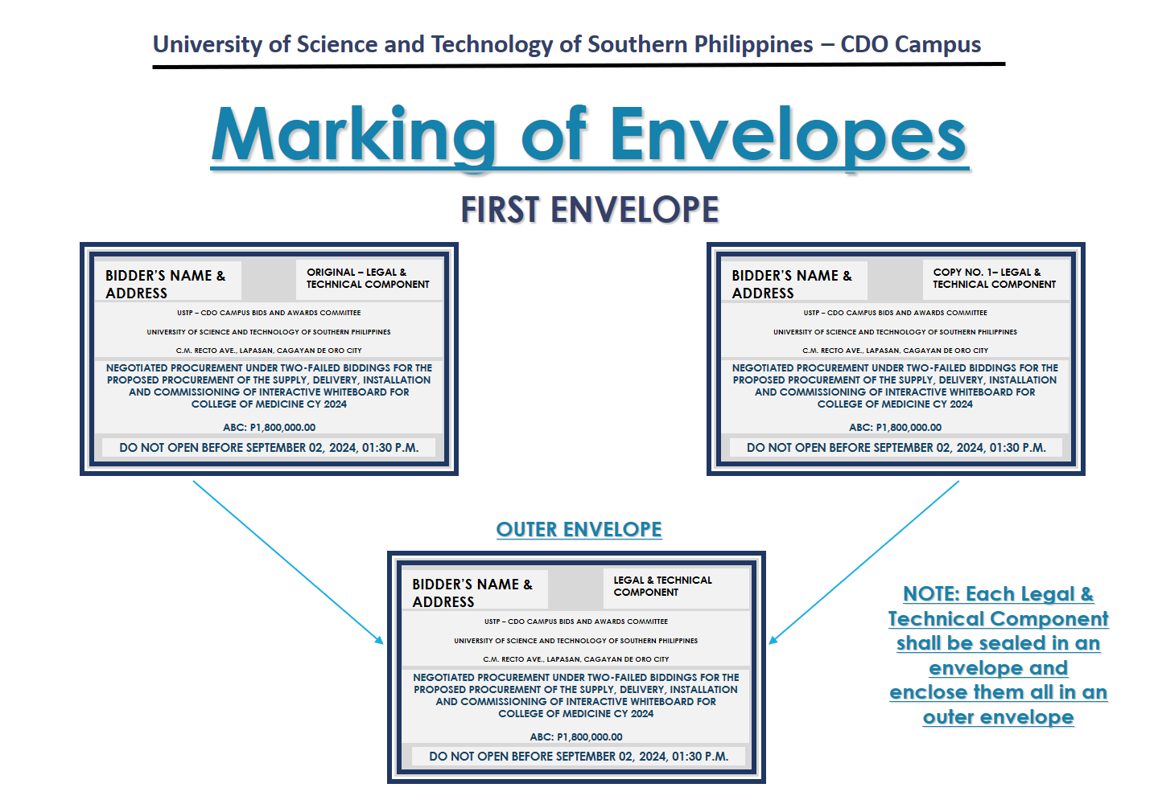

**SECOND ENVELOPE**

Original – Financial Component

**BIDDER’S NAME & ADDRESS**

**ORIGINAL – FINANCIAL COMPONENT**

**USTP – CDO CAMPUS BIDS AND AWARDS COMMITTEE**

**UNIVERSITY OF SCIENCE AND TECHNOLOGY OF SOUTHERN PHILIPPINES**

**C.M. RECTO AVE., LAPASAN, CAGAYAN DE ORO CITY**

**NEGOTIATED PROCUREMENT UNDER TWO-FAILED BIDDINGS FOR THE PROPOSED PROCUREMENT OF THE SUPPLY, DELIVERY, INSTALLATION AND COMMISSIONING OF INTERACTIVE WHITEBOARD FOR COLLEGE OF MEDICINE CY 2024**

**ABC: P1,800,000.00**

**DO NOT OPEN BEFORE SEPTEMBER 02, 2024, 01:30 P.M.**

Copy No. 1 – Financial Component

**BIDDER’S NAME & ADDRESS**

**COPY NO. 1– FINANCIAL COMPONENT**

**USTP – CDO CAMPUS BIDS AND AWARDS COMMITTEE**

**UNIVERSITY OF SCIENCE AND TECHNOLOGY OF SOUTHERN PHILIPPINES**

**C.M. RECTO AVE., LAPASAN, CAGAYAN DE ORO CITY**

**NEGOTIATED PROCUREMENT UNDER TWO-FAILED BIDDINGS FOR THE PROPOSED PROCUREMENT OF THE SUPPLY, DELIVERY, INSTALLATION AND COMMISSIONING OF INTERACTIVE WHITEBOARD FOR COLLEGE OF MEDICINE CY 2024**

**ABC: P1,800,000.00**

**DO NOT OPEN BEFORE SEPTEMBER 02, 2024, 01:30 P.M.**

**OUTER** – Financial Component

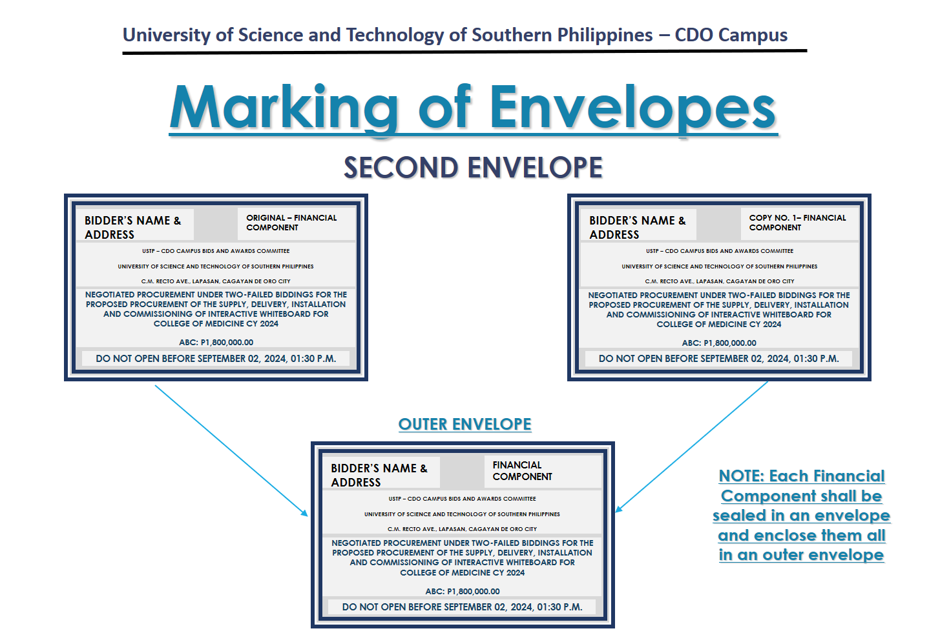

**BIDDER’S NAME & ADDRESS**

**FINANCIAL COMPONENT**

**NEGOTIATED PROCUREMENT UNDER TWO-FAILED BIDDINGS FOR THE PROPOSED PROCUREMENT OF THE SUPPLY, DELIVERY, INSTALLATION AND COMMISSIONING OF INTERACTIVE WHITEBOARD FOR COLLEGE OF MEDICINE CY 2024**

**ABC: P1,800,000.00**

**DO NOT OPEN BEFORE SEPTEMBER 02, 2024, 01:30 P.M.**

**USTP – CDO CAMPUS BIDS AND AWARDS COMMITTEE**

**UNIVERSITY OF SCIENCE AND TECHNOLOGY OF SOUTHERN PHILIPPINES**

**C.M. RECTO AVE., LAPASAN, CAGAYAN DE ORO CITY**

**OUTER ENVELOPE**

**BIDDER’S NAME & ADDRESS**

**NEGOTIATED PROCUREMENT UNDER TWO-FAILED BIDDINGS FOR THE PROPOSED PROCUREMENT OF THE SUPPLY, DELIVERY, INSTALLATION AND COMMISSIONING OF INTERACTIVE WHITEBOARD FOR COLLEGE OF MEDICINE CY 2024**

**ABC: P1,800,000.00**

**DO NOT OPEN BEFORE SEPTEMBER 02, 2024, 01:30 P.M.**

**USTP – CDO CAMPUS BIDS AND AWARDS COMMITTEE**

**UNIVERSITY OF SCIENCE AND TECHNOLOGY OF SOUTHERN PHILIPPINES**

**C.M. RECTO AVE., LAPASAN, CAGAYAN DE ORO CITY**

