MARKING OF ENVELOPES

FIRST BID ENVELOPE
Original – Technical Documents
BIDDER’S NAME & ADDRESS
ORIGINAL – TECHNICAL DOCUMENTS
SECOND RE-BIDDING FOR THE PROPOSED CONSTRUCTION OF INNOVATION AND COLLABORATION HUB PHASE II, ALUBIJID (MAIN) CAMPUS CY 2026
(Contract No. USTP-IFPB04-10-2026-43-25769)

ABC: P50,000,000.00
DO NOT OPEN BEFORE NOVEMBER 04, 2026, 01:30 P.M.
USTP – CDO CAMPUS BIDS AND AWARDS COMMITTEE
UNIVERSITY OF SCIENCE AND TECHNOLOGY OF SOUTHERN PHILIPPINES
C.M. RECTO AVE., LAPASAN, CAGAYAN DE ORO CITY

USTsP - CDO Campus Bids And Awards Committee
University of Science and Technology of Southern Philippines
C.M. Recto Ave., Lapasan, Cagayan de Oro City

Copy No. 1 – Technical Documents
BIDDER’S NAME & ADDRESS
COPY NO. 1 – TECHNICAL DOCUMENTS

SECOND RE-BIDDING FOR THE PROPOSED CONSTRUCTION OF INNOVATION AND COLLABORATION HUB PHASE II, ALUBIJID (MAIN) CAMPUS CY 2026
(Contract No. USTP-IFPB04-10-2026-43-25769)
ABC: P50,000,000.00

ABC: P50,000,000.00
DO NOT OPEN BEFORE NOVEMBER 04, 2026, 01:30 P.M.

USTP – CDO CAMPUS BIDS AND AWARDS COMMITTEE
UNIVERSITY OF SCIENCE AND TECHNOLOGY OF SOUTHERN PHILIPPINES
C.M. RECTO AVE., LAPASAN, CAGAYAN DE ORO CITY

OUTER – Technical Documents
BIDDER’S NAME & ADDRESS
TECHNICAL DOCUMENTS
SECOND RE-BIDDING FOR THE PROPOSED CONSTRUCTION OF INNOVATION AND COLLABORATION HUB PHASE II, ALUBIJID (MAIN) CAMPUS CY 2026
(Contract No. USTP-IFPB04-10-2026-43-25769)

ABC: P50,000,000.00
DO NOT OPEN BEFORE NOVEMBER 04, 2026, 01:30 P.M.

USTP – CDO CAMPUS BIDS AND AWARDS COMMITTEE
UNIVERSITY OF SCIENCE AND TECHNOLOGY OF SOUTHERN PHILIPPINES
C.M. RECTO AVE., LAPASAN, CAGAYAN DE ORO CITY

USTsP - CDO Campus Bids And Awards Committee
University of Science and Technology of Southern Philippines
C.M. Recto Ave., Lapasan, Cagayan de Oro City

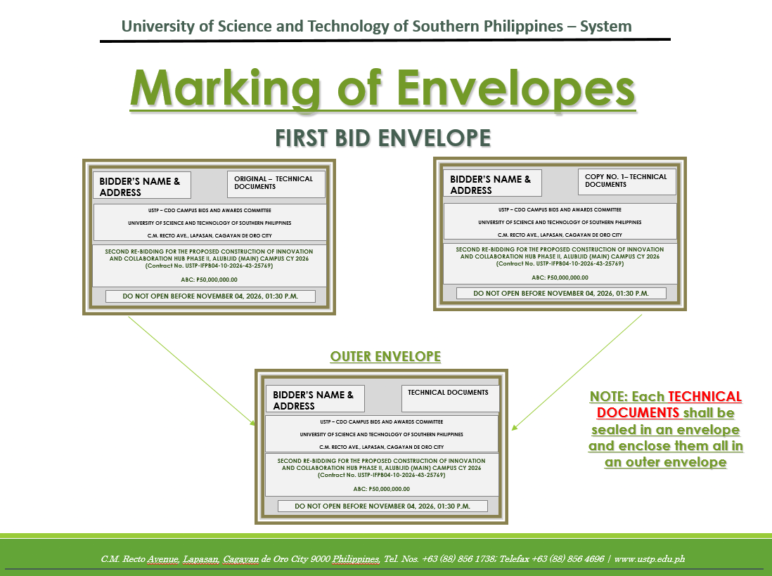

SECOND BID ENVELOPE
Original – Financial Documents
BIDDER’S NAME & ADDRESS
ORIGINAL – FINANCIAL DOCUMENTS
SECOND RE-BIDDING FOR THE PROPOSED CONSTRUCTION OF INNOVATION AND COLLABORATION HUB PHASE II, ALUBIJID (MAIN) CAMPUS CY 2026
(Contract No. USTP-IFPB04-10-2026-43-25769)

ABC: P50,000,000.00

DO NOT OPEN BEFORE NOVEMBER 04, 2026, 01:30 P.M.

USTP – CDO CAMPUS BIDS AND AWARDS COMMITTEE
UNIVERSITY OF SCIENCE AND TECHNOLOGY OF SOUTHERN PHILIPPINES
C.M. RECTO AVE., LAPASAN, CAGAYAN DE ORO CITY

Copy No. 1 – Financial Documents
BIDDER’S NAME & ADDRESS
COPY NO. 1– FINANCIAL DOCUMENTS

SECOND RE-BIDDING FOR THE PROPOSED CONSTRUCTION OF INNOVATION AND COLLABORATION HUB PHASE II, ALUBIJID (MAIN) CAMPUS CY 2026
(Contract No. USTP-IFPB04-10-2026-43-25769)

ABC: P50,000,000.00

DO NOT OPEN BEFORE NOVEMBER 04, 2026, 01:30 P.M.

USTP – CDO CAMPUS BIDS AND AWARDS COMMITTEE
UNIVERSITY OF SCIENCE AND TECHNOLOGY OF SOUTHERN PHILIPPINES
C.M. RECTO AVE., LAPASAN, CAGAYAN DE ORO CITY

OUTER – Financial Documents
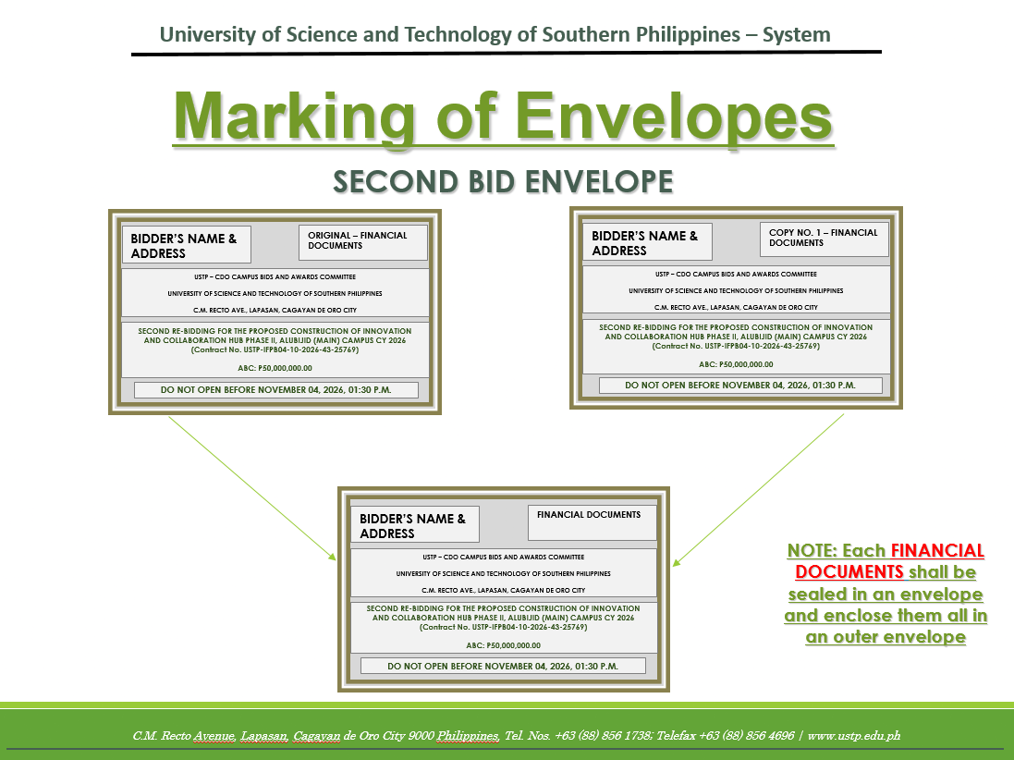
BIDDER’S NAME & ADDRESS
FINANCIAL DOCUMENTS
SECOND RE-BIDDING FOR THE PROPOSED CONSTRUCTION OF INNOVATION AND COLLABORATION HUB PHASE II, ALUBIJID (MAIN) CAMPUS CY 2026
(Contract No. USTP-IFPB04-10-2026-43-25769)

ABC: P50,000,000.00

DO NOT OPEN BEFORE NOVEMBER 04, 2026, 01:30 P.M.

USTP – CDO CAMPUS BIDS AND AWARDS COMMITTEE
UNIVERSITY OF SCIENCE AND TECHNOLOGY OF SOUTHERN PHILIPPINES
C.M. RECTO AVE., LAPASAN, CAGAYAN DE ORO CITY

OUTER ENVELOPE
BIDDER’S NAME & ADDRESS
SECOND RE-BIDDING FOR THE PROPOSED CONSTRUCTION OF INNOVATION AND COLLABORATION HUB PHASE II, ALUBIJID (MAIN) CAMPUS CY 2026
(Contract No. USTP-IFPB04-10-2026-43-25769)

ABC: P50,000,000.00

DO NOT OPEN BEFORE NOVEMBER 04, 2026, 01:30 P.M.

USTP – CDO CAMPUS BIDS AND AWARDS COMMITTEE
UNIVERSITY OF SCIENCE AND TECHNOLOGY OF SOUTHERN PHILIPPINES
C.M. RECTO AVE., LAPASAN, CAGAYAN DE ORO CITY

