MARKING OF ENVELOPES

FIRST BID ENVELOPE
Original – Technical Documents
BIDDER’S NAME & ADDRESS
ORIGINAL – TECHNICAL DOCUMENTS
Proposed Construction of Multi-Purpose Building for USTP-Jasaan Campus for CY 2026
(Contract No. USTP-IFPB08-10-2026-1226-36410)

ABC: P5,250,000.00

DO NOT OPEN BEFORE NOVEMBER 24, 2026, 09:30 A.M.
USTP – CDO CAMPUS BIDS AND AWARDS COMMITTEE
UNIVERSITY OF SCIENCE AND TECHNOLOGY OF SOUTHERN PHILIPPINES
C.M. RECTO AVE., LAPASAN, CAGAYAN DE ORO CITY

USTsP - CDO Campus Bids And Awards Committee
University of Science and Technology of Southern Philippines
C.M. Recto Ave., Lapasan, Cagayan de Oro City

Copy No. 1 – Technical Documents
BIDDER’S NAME & ADDRESS
COPY NO. 1 – TECHNICAL DOCUMENTS

Proposed Construction of Multi-Purpose Building for USTP-Jasaan Campus for CY 2026
(Contract No. USTP-IFPB08-10-2026-1226-36410)

ABC: P5,250,000.00

DO NOT OPEN BEFORE NOVEMBER 24, 2026, 09:30 A.M.

USTP – CDO CAMPUS BIDS AND AWARDS COMMITTEE
UNIVERSITY OF SCIENCE AND TECHNOLOGY OF SOUTHERN PHILIPPINES
C.M. RECTO AVE., LAPASAN, CAGAYAN DE ORO CITY

OUTER – Technical Documents
BIDDER’S NAME & ADDRESS
TECHNICAL DOCUMENTS
Proposed Construction of Multi-Purpose Building for USTP-Jasaan Campus for CY 2026
(Contract No. USTP-IFPB08-10-2026-1226-36410)

ABC: P5,250,000.00

DO NOT OPEN BEFORE NOVEMBER 24, 2026, 09:30 A.M.

USTP – CDO CAMPUS BIDS AND AWARDS COMMITTEE
UNIVERSITY OF SCIENCE AND TECHNOLOGY OF SOUTHERN PHILIPPINES
C.M. RECTO AVE., LAPASAN, CAGAYAN DE ORO CITY

USTsP - CDO Campus Bids And Awards Committee
University of Science and Technology of Southern Philippines
C.M. Recto Ave., Lapasan, Cagayan de Oro City

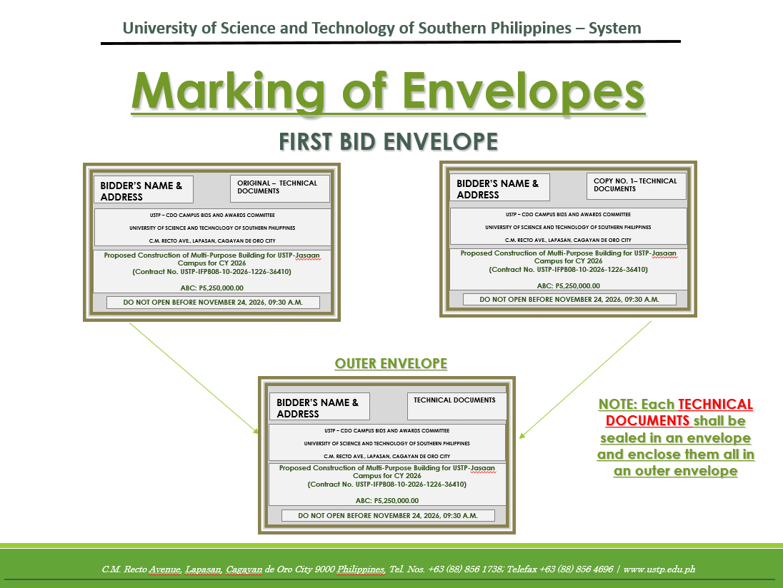

SECOND BID ENVELOPE
Original – Financial Documents
BIDDER’S NAME & ADDRESS
ORIGINAL – FINANCIAL DOCUMENTS
Proposed Construction of Multi-Purpose Building for USTP-Jasaan Campus for CY 2026
(Contract No. USTP-IFPB08-10-2026-1226-36410)

ABC: P5,250,000.00

DO NOT OPEN BEFORE NOVEMBER 24, 2026, 09:30 A.M.

USTP – CDO CAMPUS BIDS AND AWARDS COMMITTEE
UNIVERSITY OF SCIENCE AND TECHNOLOGY OF SOUTHERN PHILIPPINES
C.M. RECTO AVE., LAPASAN, CAGAYAN DE ORO CITY

Copy No. 1 – Financial Documents
BIDDER’S NAME & ADDRESS
COPY NO. 1– FINANCIAL DOCUMENTS

Proposed Construction of Multi-Purpose Building for USTP-Jasaan Campus for CY 2026
(Contract No. USTP-IFPB08-10-2026-1226-36410)

ABC: P5,250,000.00

DO NOT OPEN BEFORE NOVEMBER 24, 2026, 09:30 A.M.

USTP – CDO CAMPUS BIDS AND AWARDS COMMITTEE
UNIVERSITY OF SCIENCE AND TECHNOLOGY OF SOUTHERN PHILIPPINES
C.M. RECTO AVE., LAPASAN, CAGAYAN DE ORO CITY

OUTER – Financial Documents
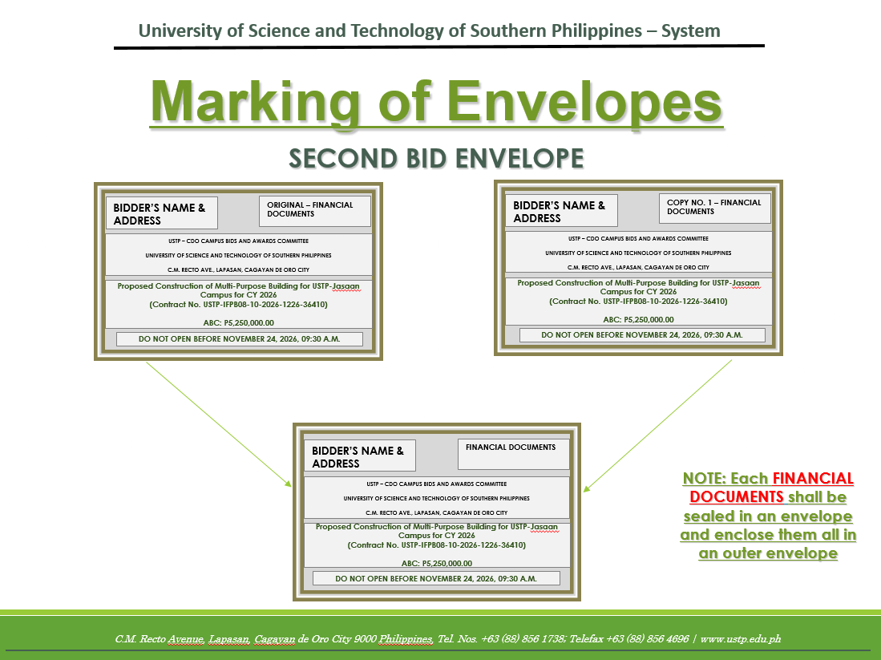
BIDDER’S NAME & ADDRESS
FINANCIAL DOCUMENTS
Proposed Construction of Multi-Purpose Building for USTP-Jasaan Campus for CY 2026
(Contract No. USTP-IFPB08-10-2026-1226-36410)

ABC: P5,250,000.00

DO NOT OPEN BEFORE NOVEMBER 24, 2026, 09:30 A.M.

USTP – CDO CAMPUS BIDS AND AWARDS COMMITTEE
UNIVERSITY OF SCIENCE AND TECHNOLOGY OF SOUTHERN PHILIPPINES
C.M. RECTO AVE., LAPASAN, CAGAYAN DE ORO CITY

OUTER ENVELOPE
BIDDER’S NAME & ADDRESS
Proposed Construction of Multi-Purpose Building for USTP-Jasaan Campus for CY 2026
(Contract No. USTP-IFPB08-10-2026-1226-36410)

ABC: P5,250,000.00

DO NOT OPEN BEFORE NOVEMBER 24, 2026, 09:30 A.M.

USTP – CDO CAMPUS BIDS AND AWARDS COMMITTEE
UNIVERSITY OF SCIENCE AND TECHNOLOGY OF SOUTHERN PHILIPPINES
C.M. RECTO AVE., LAPASAN, CAGAYAN DE ORO CITY

