MARKING OF ENVELOPES

FIRST ENVELOPE
Original – Technical Component
BIDDER’S NAME & ADDRESS
ORIGINAL – TECHNICAL COMPONENT
DO NOT OPEN BEFORE JULY 06, 2026, 01:30 P.M.
USTP – CDO CAMPUS BIDS AND AWARDS COMMITTEE
UNIVERSITY OF SCIENCE AND TECHNOLOGY OF SOUTHERN PHILIPPINES
C.M. RECTO AVE., LAPASAN, CAGAYAN DE ORO CITY

PROPOSED REPAIR AND IMPROVEMENT OF FINANCE ROOFING FOR USTP-CDO CAMPUS CY 2026
(Contract No. USTP-IFPB04-06-2026-2296-25995)

ABC: ₱3,450,000.00

USTsP - CDO Campus Bids And Awards Committee
University of Science and Technology of Southern Philippines
C.M. Recto Ave., Lapasan, Cagayan de Oro City

Copy No. 1 – Technical Component
BIDDER’S NAME & ADDRESS
COPY NO. 1 – TECHNICAL COMPONENT

PROPOSED REPAIR AND IMPROVEMENT OF FINANCE ROOFING FOR USTP-CDO CAMPUS CY 2026
(Contract No. USTP-IFPB04-06-2026-2296-25995)

ABC: ₱3,450,000.00

DO NOT OPEN BEFORE JULY 06, 2026, 01:30 P.M.

USTP – CDO CAMPUS BIDS AND AWARDS COMMITTEE
UNIVERSITY OF SCIENCE AND TECHNOLOGY OF SOUTHERN PHILIPPINES
C.M. RECTO AVE., LAPASAN, CAGAYAN DE ORO CITY

OUTER – Technical Component
BIDDER’S NAME & ADDRESS
TECHNICAL COMPONENT
DO NOT OPEN BEFORE JULY 06, 2026, 01:30 P.M.

USTP – CDO CAMPUS BIDS AND AWARDS COMMITTEE
UNIVERSITY OF SCIENCE AND TECHNOLOGY OF SOUTHERN PHILIPPINES
C.M. RECTO AVE., LAPASAN, CAGAYAN DE ORO CITY

PROPOSED REPAIR AND IMPROVEMENT OF FINANCE ROOFING FOR USTP-CDO CAMPUS CY 2026
(Contract No. USTP-IFPB04-06-2026-2296-25995)

ABC: ₱3,450,000.00

USTsP - CDO Campus Bids And Awards Committee
University of Science and Technology of Southern Philippines
C.M. Recto Ave., Lapasan, Cagayan de Oro City

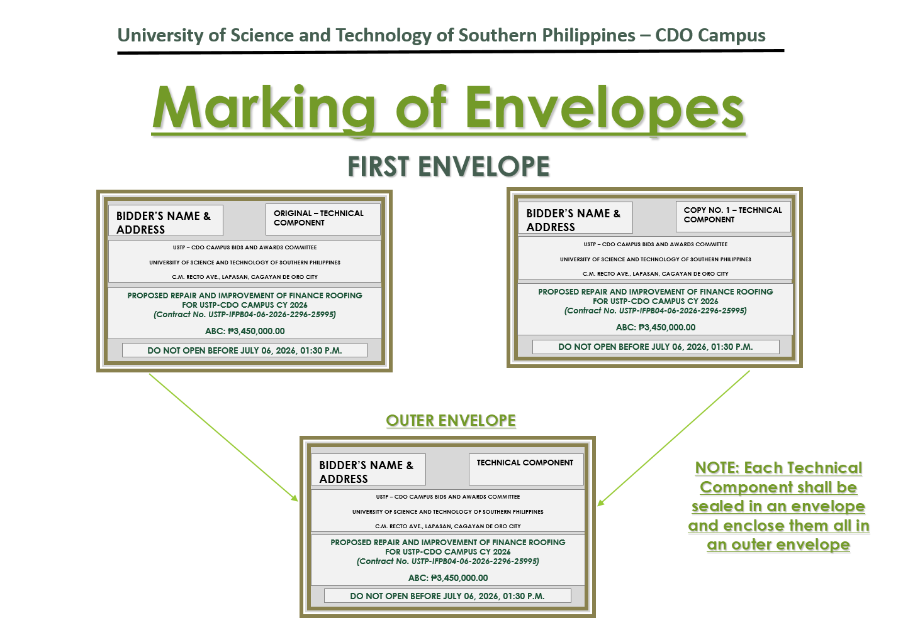

SECOND ENVELOPE
Original – Financial Component
BIDDER’S NAME & ADDRESS
ORIGINAL – FINANCIAL COMPONENT
DO NOT OPEN BEFORE JULY 06, 2026, 01:30 P.M.
USTP – CDO CAMPUS BIDS AND AWARDS COMMITTEE
UNIVERSITY OF SCIENCE AND TECHNOLOGY OF SOUTHERN PHILIPPINES
C.M. RECTO AVE., LAPASAN, CAGAYAN DE ORO CITY

PROPOSED REPAIR AND IMPROVEMENT OF FINANCE ROOFING FOR USTP-CDO CAMPUS CY 2026
(Contract No. USTP-IFPB04-06-2026-2296-25995)

ABC: ₱3,450,000.00

Copy No. 1 – Financial Component
BIDDER’S NAME & ADDRESS
COPY NO. 1– FINANCIAL COMPONENT

DO NOT OPEN BEFORE JULY 06, 2026, 01:30 P.M.
USTP – CDO CAMPUS BIDS AND AWARDS COMMITTEE
UNIVERSITY OF SCIENCE AND TECHNOLOGY OF SOUTHERN PHILIPPINES
C.M. RECTO AVE., LAPASAN, CAGAYAN DE ORO CITY

PROPOSED REPAIR AND IMPROVEMENT OF FINANCE ROOFING FOR USTP-CDO CAMPUS CY 2026
(Contract No. USTP-IFPB04-06-2026-2296-25995)

ABC: ₱3,450,000.00

OUTER – Financial Component
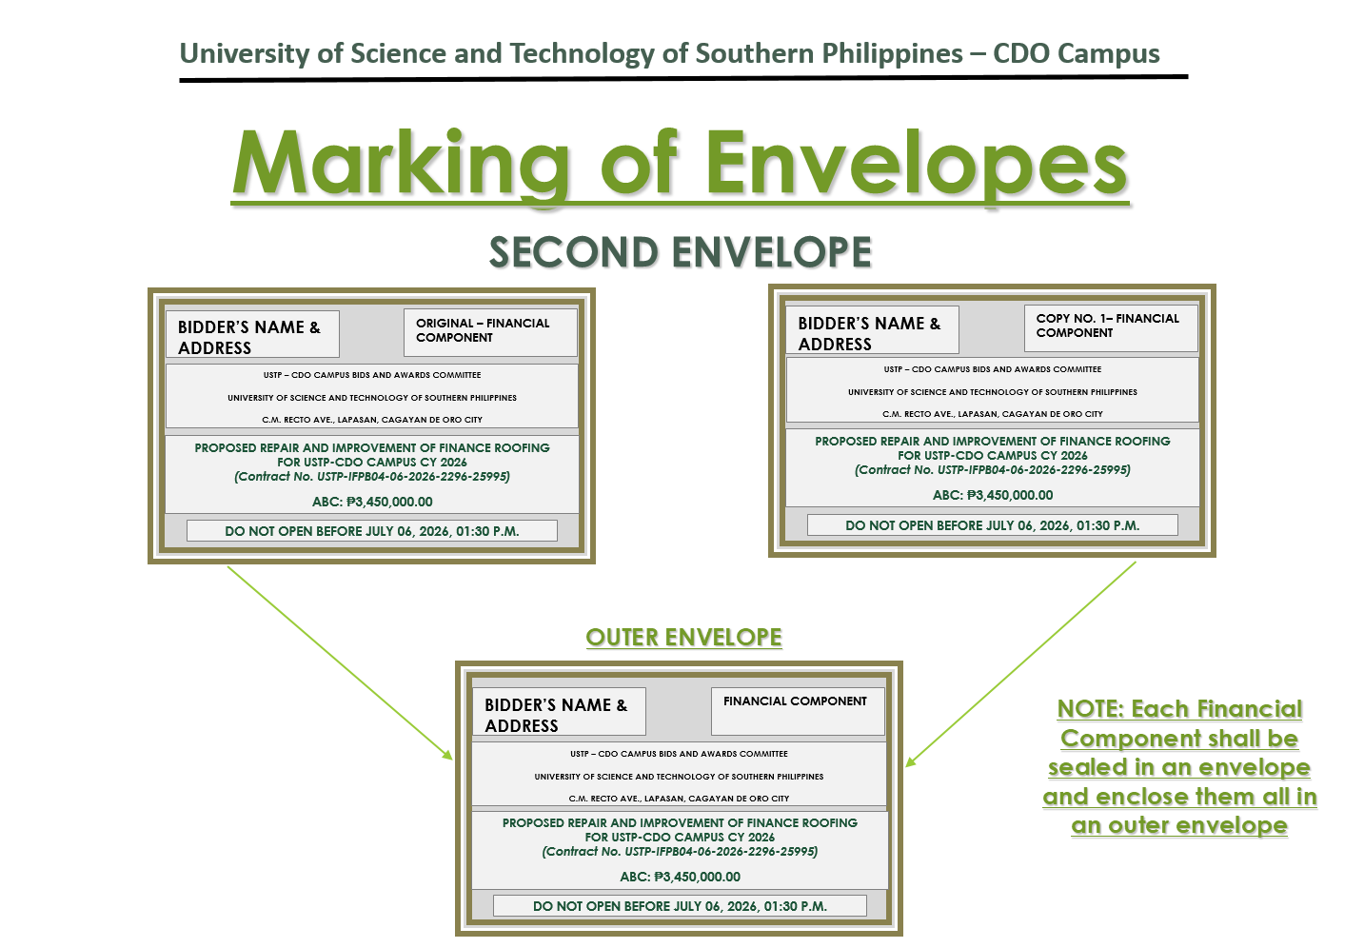
PROPOSED REPAIR AND IMPROVEMENT OF FINANCE ROOFING FOR USTP-CDO CAMPUS CY 2026
(Contract No. USTP-IFPB04-06-2026-2296-25995)

ABC: ₱3,450,000.00

BIDDER’S NAME & ADDRESS
FINANCIAL COMPONENT
DO NOT OPEN BEFORE JULY 06, 2026, 01:30 P.M.

USTP – CDO CAMPUS BIDS AND AWARDS COMMITTEE
UNIVERSITY OF SCIENCE AND TECHNOLOGY OF SOUTHERN PHILIPPINES
C.M. RECTO AVE., LAPASAN, CAGAYAN DE ORO CITY

OUTER ENVELOPE
BIDDER’S NAME & ADDRESS
PROPOSED REPAIR AND IMPROVEMENT OF FINANCE ROOFING FOR USTP-CDO CAMPUS CY 2026
(Contract No. USTP-IFPB04-06-2026-2296-25995)

ABC: ₱3,450,000.00
DO NOT OPEN BEFORE JULY 06, 2026, 01:30 P.M.

USTP – CDO CAMPUS BIDS AND AWARDS COMMITTEE
UNIVERSITY OF SCIENCE AND TECHNOLOGY OF SOUTHERN PHILIPPINES
C.M. RECTO AVE., LAPASAN, CAGAYAN DE ORO CITY

