MARKING OF ENVELOPES

FIRST ENVELOPE
Original – Technical Component
BIDDER’S NAME & ADDRESS
ORIGINAL – TECHNICAL COMPONENT
DO NOT OPEN BEFORE AUGUST 03, 2026, 09:30 A.M.

USTP – CDO CAMPUS BIDS AND AWARDS COMMITTEE
UNIVERSITY OF SCIENCE AND TECHNOLOGY OF SOUTHERN PHILIPPINES
C.M. RECTO AVE., LAPASAN, CAGAYAN DE ORO CITY

RE-BIDDING FOR THE PROPOSED REPAIR AND IMPROVEMENT OF FINANCE ROOFING FOR USTP-CDO CAMPUS CY 2026
(Contract No. USTP-IFPB07-07-2026-2296-25995)

ABC: ₱3,450,000.00

USTsP - CDO Campus Bids And Awards Committee
University of Science and Technology of Southern Philippines
C.M. Recto Ave., Lapasan, Cagayan de Oro City

Copy No. 1 – Technical Component
BIDDER’S NAME & ADDRESS
COPY NO. 1 – TECHNICAL COMPONENT

RE-BIDDING FOR THE PROPOSED REPAIR AND IMPROVEMENT OF FINANCE ROOFING FOR USTP-CDO CAMPUS CY 2026
(Contract No. USTP-IFPB07-07-2026-2296-25995)

ABC: ₱3,450,000.00

DO NOT OPEN BEFORE AUGUST 03, 2026, 09:30 A.M.

USTP – CDO CAMPUS BIDS AND AWARDS COMMITTEE
UNIVERSITY OF SCIENCE AND TECHNOLOGY OF SOUTHERN PHILIPPINES
C.M. RECTO AVE., LAPASAN, CAGAYAN DE ORO CITY

OUTER – Technical Component
BIDDER’S NAME & ADDRESS
TECHNICAL COMPONENT
DO NOT OPEN BEFORE AUGUST 03, 2026, 09:30 A.M.

USTP – CDO CAMPUS BIDS AND AWARDS COMMITTEE
UNIVERSITY OF SCIENCE AND TECHNOLOGY OF SOUTHERN PHILIPPINES
C.M. RECTO AVE., LAPASAN, CAGAYAN DE ORO CITY

RE-BIDDING FOR THE PROPOSED REPAIR AND IMPROVEMENT OF FINANCE ROOFING FOR USTP-CDO CAMPUS CY 2026
(Contract No. USTP-IFPB07-07-2026-2296-25995)

ABC: ₱3,450,000.00

USTsP - CDO Campus Bids And Awards Committee
University of Science and Technology of Southern Philippines
C.M. Recto Ave., Lapasan, Cagayan de Oro City

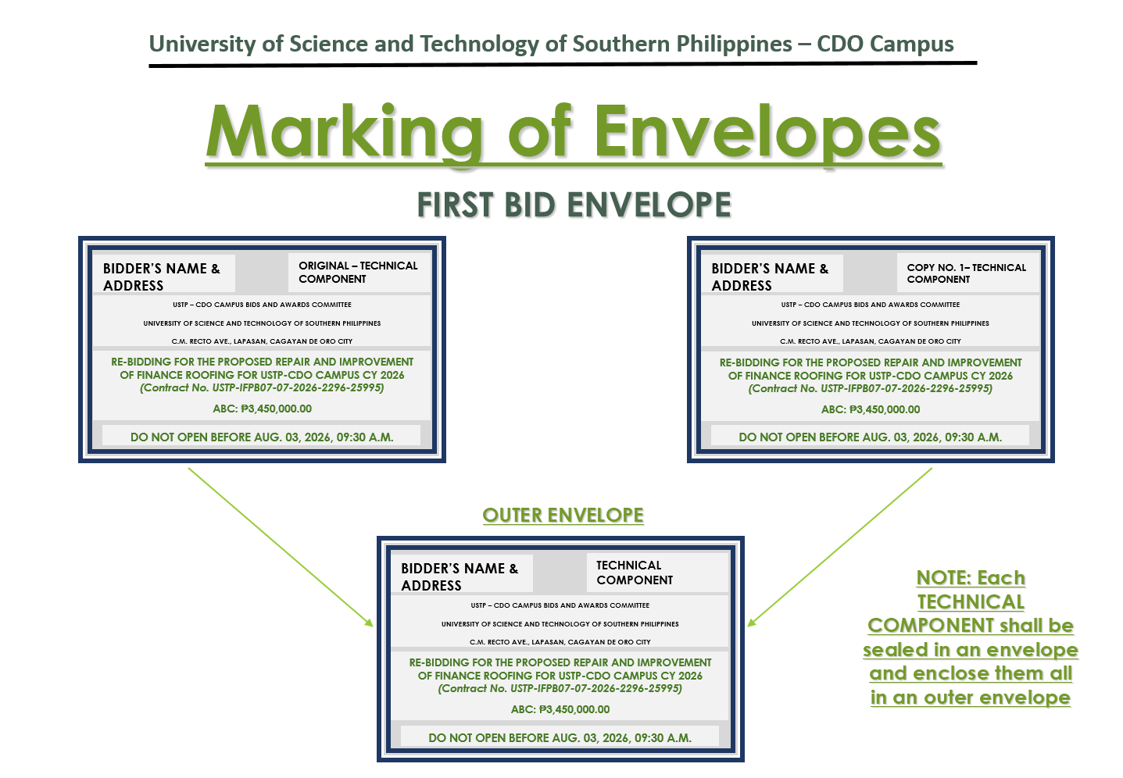

SECOND ENVELOPE
Original – Financial Component
BIDDER’S NAME & ADDRESS
ORIGINAL – FINANCIAL COMPONENT
DO NOT OPEN BEFORE AUGUST 03, 2026, 09:30 A.M.

USTP – CDO CAMPUS BIDS AND AWARDS COMMITTEE
UNIVERSITY OF SCIENCE AND TECHNOLOGY OF SOUTHERN PHILIPPINES
C.M. RECTO AVE., LAPASAN, CAGAYAN DE ORO CITY

RE-BIDDING FOR THE PROPOSED REPAIR AND IMPROVEMENT OF FINANCE ROOFING FOR USTP-CDO CAMPUS CY 2026
(Contract No. USTP-IFPB07-07-2026-2296-25995)

ABC: ₱3,450,000.00

Copy No. 1 – Financial Component
BIDDER’S NAME & ADDRESS
COPY NO. 1– FINANCIAL COMPONENT

DO NOT OPEN BEFORE AUGUST 03, 2026, 09:30 A.M.

USTP – CDO CAMPUS BIDS AND AWARDS COMMITTEE
UNIVERSITY OF SCIENCE AND TECHNOLOGY OF SOUTHERN PHILIPPINES
C.M. RECTO AVE., LAPASAN, CAGAYAN DE ORO CITY

RE-BIDDING FOR THE PROPOSED REPAIR AND IMPROVEMENT OF FINANCE ROOFING FOR USTP-CDO CAMPUS CY 2026
(Contract No. USTP-IFPB07-07-2026-2296-25995)

ABC: ₱3,450,000.00

OUTER – Financial Component
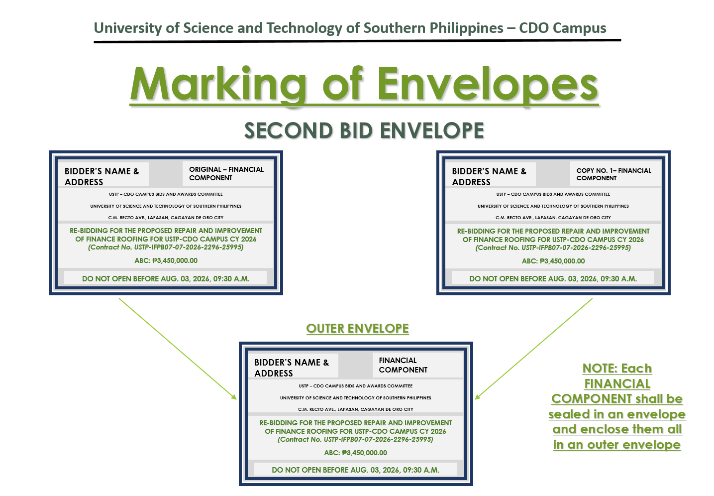
RE-BIDDING FOR THE PROPOSED REPAIR AND IMPROVEMENT OF FINANCE ROOFING FOR USTP-CDO CAMPUS CY 2026
(Contract No. USTP-IFPB07-07-2026-2296-25995)

ABC: ₱3,450,000.00

BIDDER’S NAME & ADDRESS
FINANCIAL COMPONENT
DO NOT OPEN BEFORE AUGUST 03, 2026, 09:30 A.M.

USTP – CDO CAMPUS BIDS AND AWARDS COMMITTEE
UNIVERSITY OF SCIENCE AND TECHNOLOGY OF SOUTHERN PHILIPPINES
C.M. RECTO AVE., LAPASAN, CAGAYAN DE ORO CITY

OUTER ENVELOPE
BIDDER’S NAME & ADDRESS
RE-BIDDING FOR THE PROPOSED REPAIR AND IMPROVEMENT OF FINANCE ROOFING FOR USTP-CDO CAMPUS CY 2026
(Contract No. USTP-IFPB07-07-2026-2296-25995)

ABC: ₱3,450,000.00
DO NOT OPEN BEFORE AUGUST 03, 2026, 09:30 A.M.

USTP – CDO CAMPUS BIDS AND AWARDS COMMITTEE
UNIVERSITY OF SCIENCE AND TECHNOLOGY OF SOUTHERN PHILIPPINES
C.M. RECTO AVE., LAPASAN, CAGAYAN DE ORO CITY

