MARKING OF ENVELOPES

FIRST ENVELOPE
Original – Technical Component
BIDDER’S NAME & ADDRESS
ORIGINAL – TECHNICAL COMPONENT
DO NOT OPEN BEFORE OCTOBER 19, 2026, 09:30 A.M.
USTP – CDO CAMPUS BIDS AND AWARDS COMMITTEE
UNIVERSITY OF SCIENCE AND TECHNOLOGY OF SOUTHERN PHILIPPINES
C.M. RECTO AVE., LAPASAN, CAGAYAN DE ORO CITY

PROPOSED CONSTRUCTION OF THE COMMERCIAL SPACE FOR THE 8-STOREY STUDENT CENTER, INNOVATION HUB AND EDUCATIONAL COMPLEX
AT USTP-CDO CAMPUS CY 2026
(Contract No. USTP-IFPB09-09-2026-2424-26921)

ABC: ₱3,348,676.00

USTsP - CDO Campus Bids And Awards Committee
University of Science and Technology of Southern Philippines
C.M. Recto Ave., Lapasan, Cagayan de Oro City

Copy No. 1 – Technical Component
BIDDER’S NAME & ADDRESS
COPY NO. 1 – TECHNICAL COMPONENT

PROPOSED CONSTRUCTION OF THE COMMERCIAL SPACE FOR THE 8-STOREY STUDENT CENTER, INNOVATION HUB AND EDUCATIONAL COMPLEX
AT USTP-CDO CAMPUS CY 2026
(Contract No. USTP-IFPB09-09-2026-2424-26921)

ABC: ₱3,348,676.00

DO NOT OPEN BEFORE OCTOBER 19, 2026, 09:30 A.M.

USTP – CDO CAMPUS BIDS AND AWARDS COMMITTEE
UNIVERSITY OF SCIENCE AND TECHNOLOGY OF SOUTHERN PHILIPPINES
C.M. RECTO AVE., LAPASAN, CAGAYAN DE ORO CITY

OUTER – Technical Component
BIDDER’S NAME & ADDRESS
TECHNICAL COMPONENT
DO NOT OPEN BEFORE OCTOBER 19, 2026, 09:30 A.M.

USTP – CDO CAMPUS BIDS AND AWARDS COMMITTEE
UNIVERSITY OF SCIENCE AND TECHNOLOGY OF SOUTHERN PHILIPPINES
C.M. RECTO AVE., LAPASAN, CAGAYAN DE ORO CITY

PROPOSED CONSTRUCTION OF THE COMMERCIAL SPACE FOR THE 8-STOREY STUDENT CENTER, INNOVATION HUB AND EDUCATIONAL COMPLEX
AT USTP-CDO CAMPUS CY 2026
(Contract No. USTP-IFPB09-09-2026-2424-26921)

ABC: ₱3,348,676.00

USTsP - CDO Campus Bids And Awards Committee
University of Science and Technology of Southern Philippines
C.M. Recto Ave., Lapasan, Cagayan de Oro City

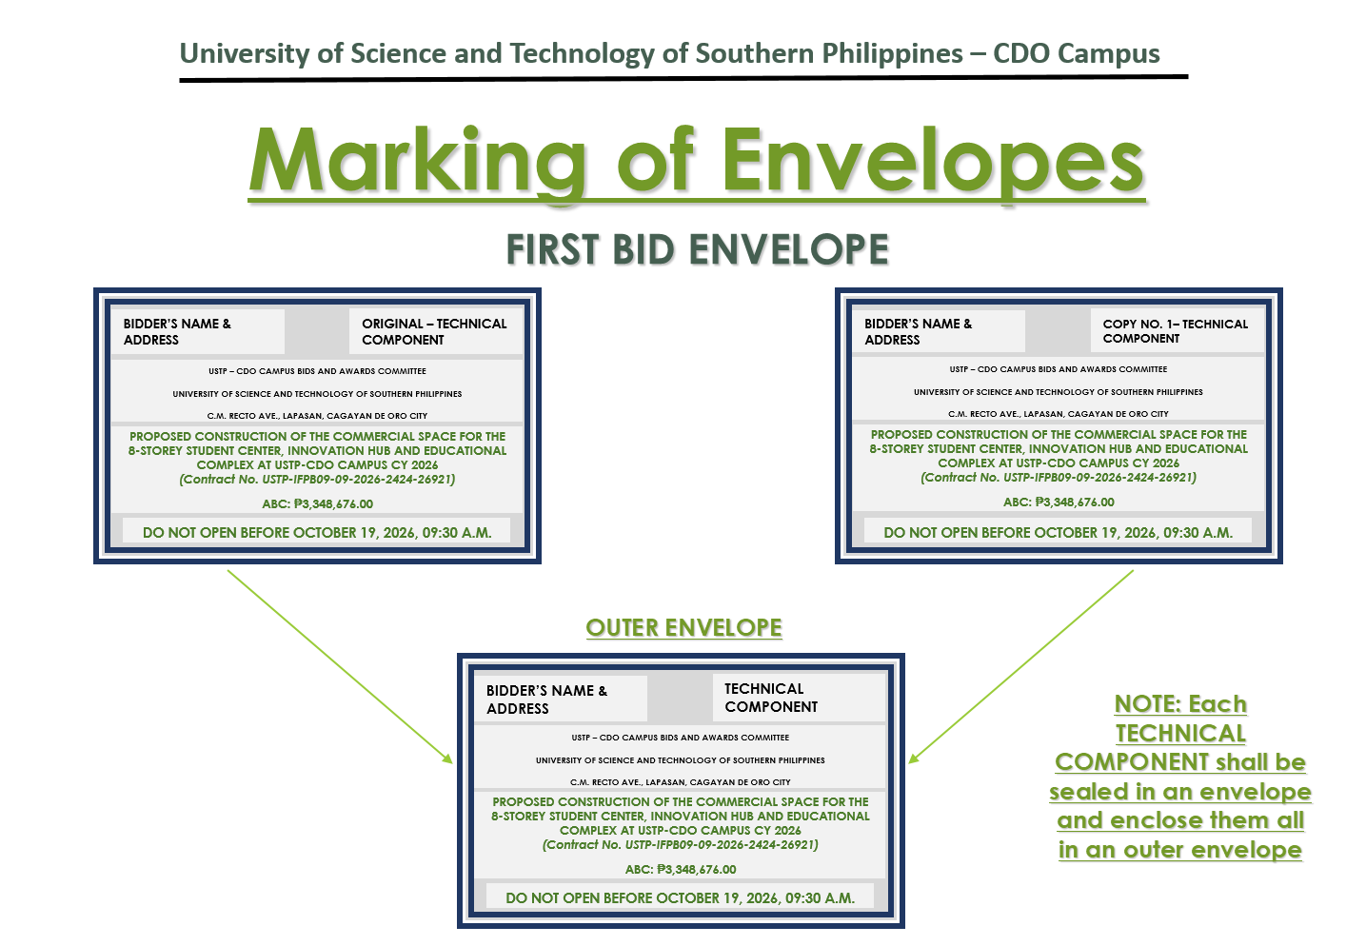

SECOND ENVELOPE
Original – Financial Component
BIDDER’S NAME & ADDRESS
ORIGINAL – FINANCIAL COMPONENT
DO NOT OPEN BEFORE OCTOBER 19, 2026, 09:30 A.M.

USTP – CDO CAMPUS BIDS AND AWARDS COMMITTEE
UNIVERSITY OF SCIENCE AND TECHNOLOGY OF SOUTHERN PHILIPPINES
C.M. RECTO AVE., LAPASAN, CAGAYAN DE ORO CITY

PROPOSED CONSTRUCTION OF THE COMMERCIAL SPACE FOR THE 8-STOREY STUDENT CENTER, INNOVATION HUB AND EDUCATIONAL COMPLEX
AT USTP-CDO CAMPUS CY 2026
(Contract No. USTP-IFPB09-09-2026-2424-26921)

ABC: ₱3,348,676.00

Copy No. 1 – Financial Component
BIDDER’S NAME & ADDRESS
COPY NO. 1– FINANCIAL COMPONENT

DO NOT OPEN BEFORE OCTOBER 19, 2026, 09:30 A.M.

USTP – CDO CAMPUS BIDS AND AWARDS COMMITTEE
UNIVERSITY OF SCIENCE AND TECHNOLOGY OF SOUTHERN PHILIPPINES
C.M. RECTO AVE., LAPASAN, CAGAYAN DE ORO CITY

PROPOSED CONSTRUCTION OF THE COMMERCIAL SPACE FOR THE 8-STOREY STUDENT CENTER, INNOVATION HUB AND EDUCATIONAL COMPLEX
AT USTP-CDO CAMPUS CY 2026
(Contract No. USTP-IFPB09-09-2026-2424-26921)

ABC: ₱3,348,676.00

OUTER – Financial Component
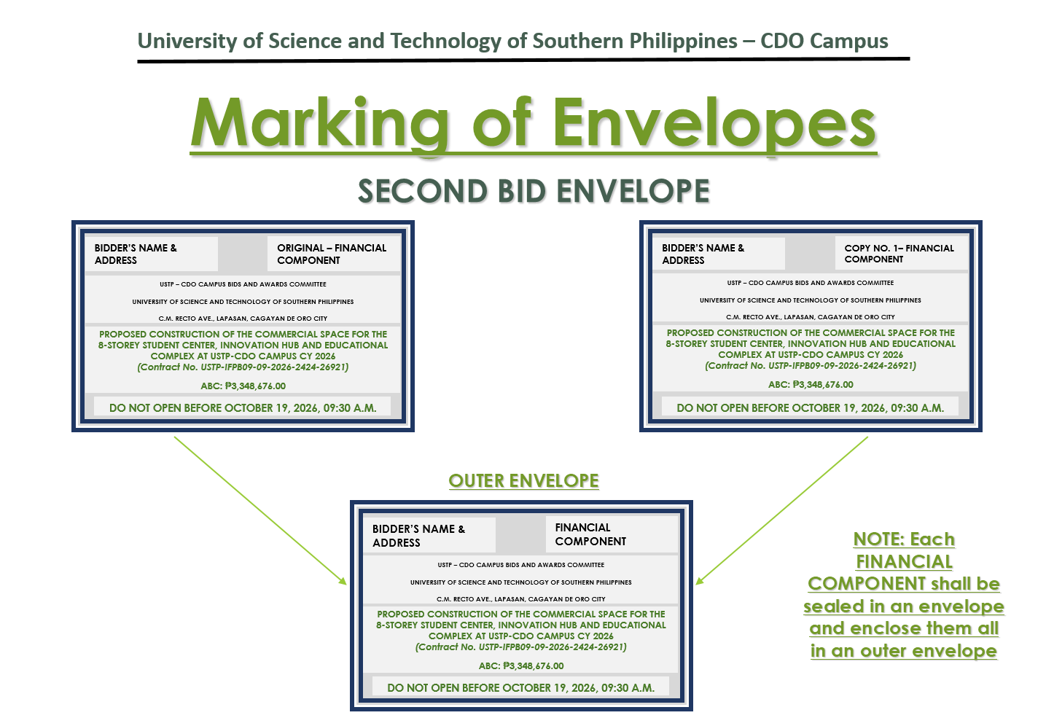
PROPOSED CONSTRUCTION OF THE COMMERCIAL SPACE FOR THE 8-STOREY STUDENT CENTER, INNOVATION HUB AND EDUCATIONAL COMPLEX
AT USTP-CDO CAMPUS CY 2026
(Contract No. USTP-IFPB09-09-2026-2424-26921)

ABC: ₱3,348,676.00

BIDDER’S NAME & ADDRESS
FINANCIAL COMPONENT
DO NOT OPEN BEFORE OCTOBER 19, 2026, 09:30 A.M.

USTP – CDO CAMPUS BIDS AND AWARDS COMMITTEE
UNIVERSITY OF SCIENCE AND TECHNOLOGY OF SOUTHERN PHILIPPINES
C.M. RECTO AVE., LAPASAN, CAGAYAN DE ORO CITY

OUTER ENVELOPE
BIDDER’S NAME & ADDRESS
PROPOSED CONSTRUCTION OF THE COMMERCIAL SPACE FOR THE 8-STOREY STUDENT CENTER, INNOVATION HUB AND EDUCATIONAL COMPLEX AT USTP-CDO CAMPUS CY 2026
(Contract No. USTP-IFPB09-09-2026-2424-26921)

ABC: ₱3,348,676.00

DO NOT OPEN BEFORE OCTOBER 19, 2026, 09:30 A.M.

USTP – CDO CAMPUS BIDS AND AWARDS COMMITTEE
UNIVERSITY OF SCIENCE AND TECHNOLOGY OF SOUTHERN PHILIPPINES
C.M. RECTO AVE., LAPASAN, CAGAYAN DE ORO CITY

